**DAILY ONLINE ACTIVITIES SUMMARY**

|  |  |  |  |  |  |  |  |  |
| --- | --- | --- | --- | --- | --- | --- | --- | --- |
| **Date:** | **01-06-2020** | | | | | **Name:** | **ROUSHA** | |
| **Sem & Sec** | **6 B** | | | | | **USN:** | **4AL17CS079** | |
| **Online Test Summary** | | | | | | | | |
| **Subject** | | **CRYPTOGRAPHY,**  **NETWORK SECURITY AMD CYBER LAWS** | | | | | | |
| **Max. Marks** | | **60** | | **Score** | | | **52** | |
| **Certification Course Summary** | | | | | | | | |
| **Course** | **Python for Data Science** | | | | | | | |
| **Certificate Provider** | | | **Cognitive classes** | | **Duration** | | | **5 Days** |
| **Coding Challenges** | | | | | | | | |
| **Problem Statement: 1 Python program** | | | | | | | | |
| **Status: Executed** | | | | | | | | |
| **Uploaded the report in Github** | | | | | **Yes** | | | |
| **If yes Repository name** | | | | | |  | | --- | | **https://github.com/rousharousha/DailyReport.git** | | | | |
| **Uploaded the report in slack** | | | | | **Yes** | | | |

Online Test Details: (Attach the snapshot and briefly write the report for the same)

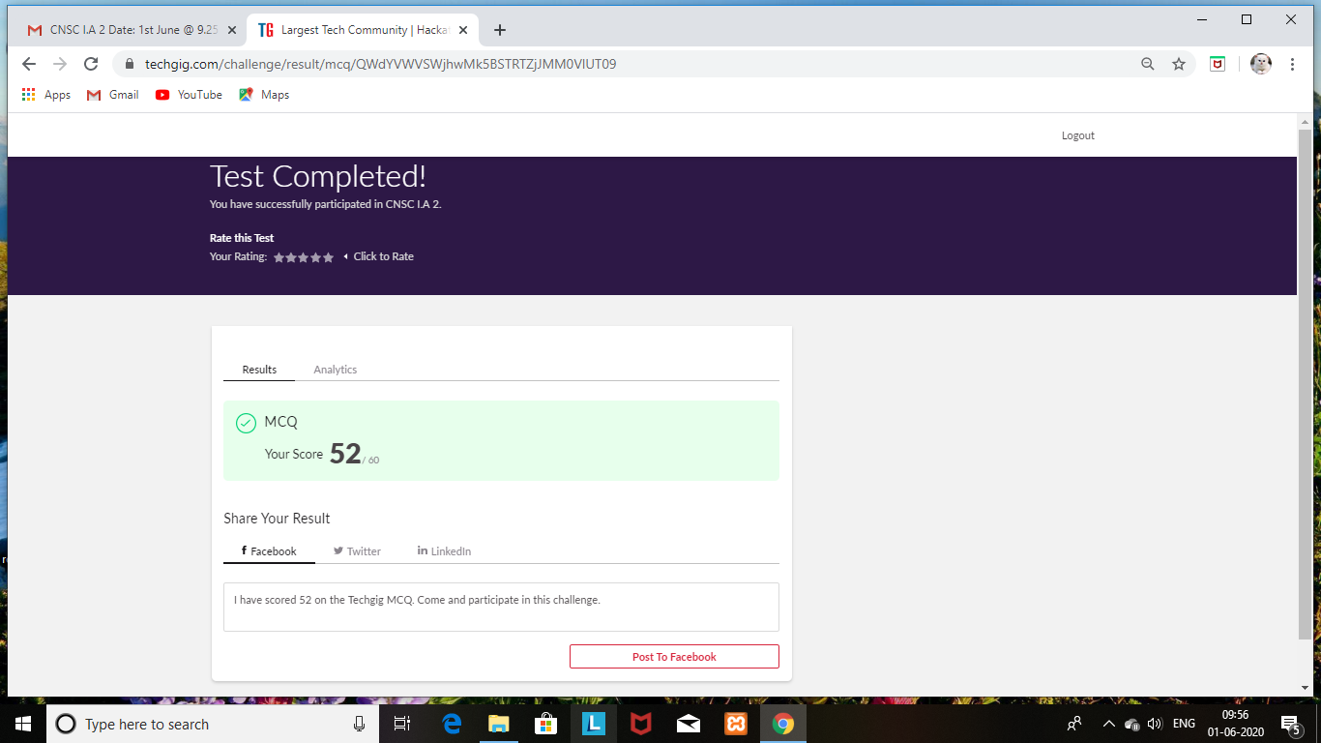

Certification Course Details: (Attach the snapshot and briefly write the report for the same)

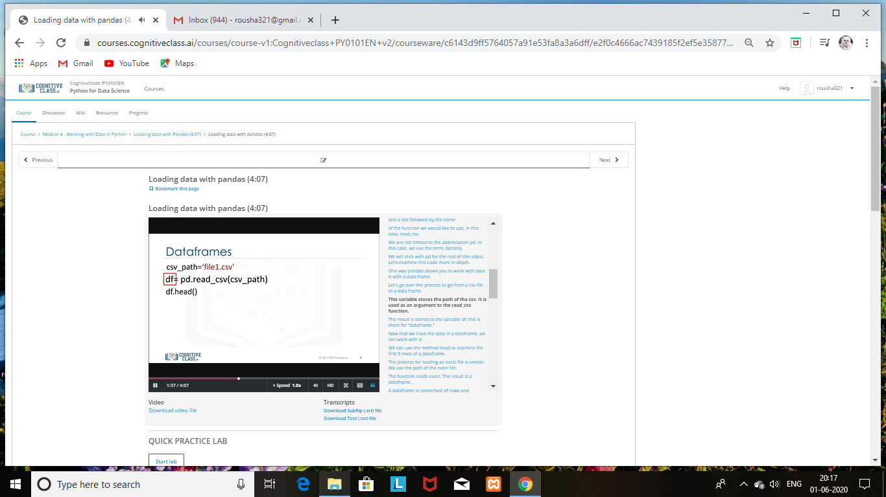

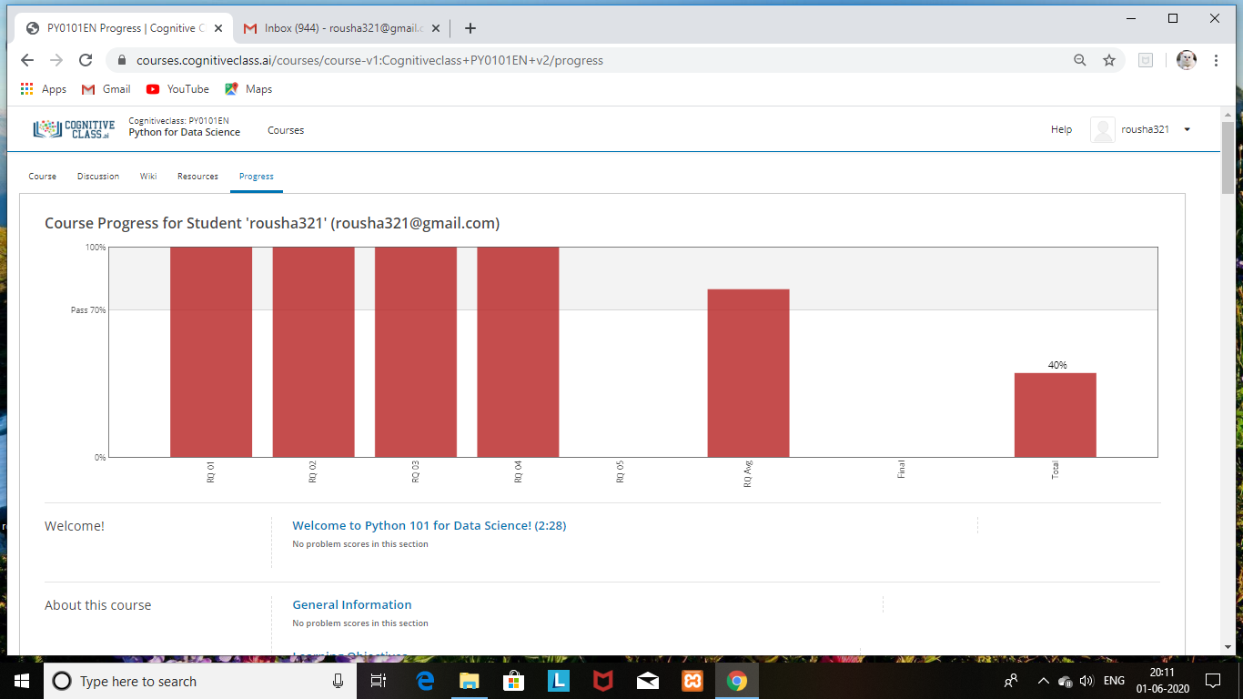

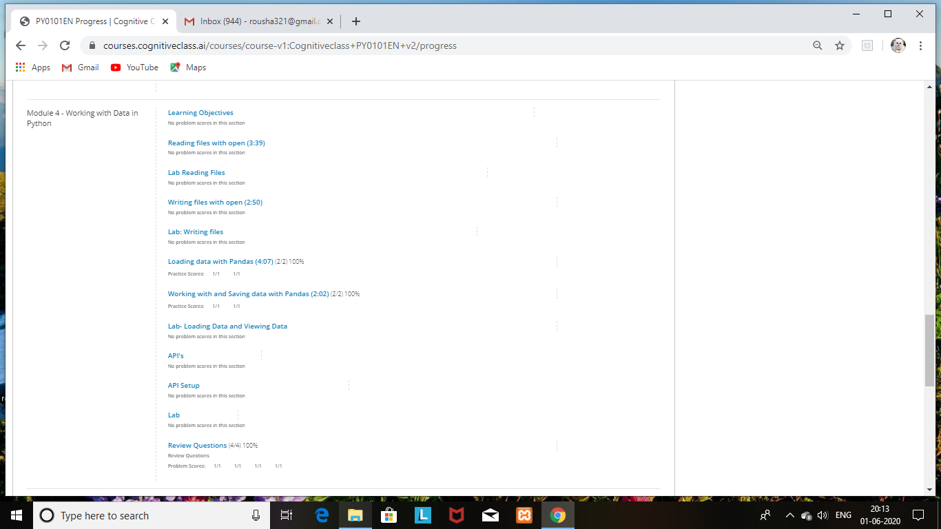

Completed one module of Day 4.

Completed the course on Robotic Process Automation and posted the certificate in github repository.

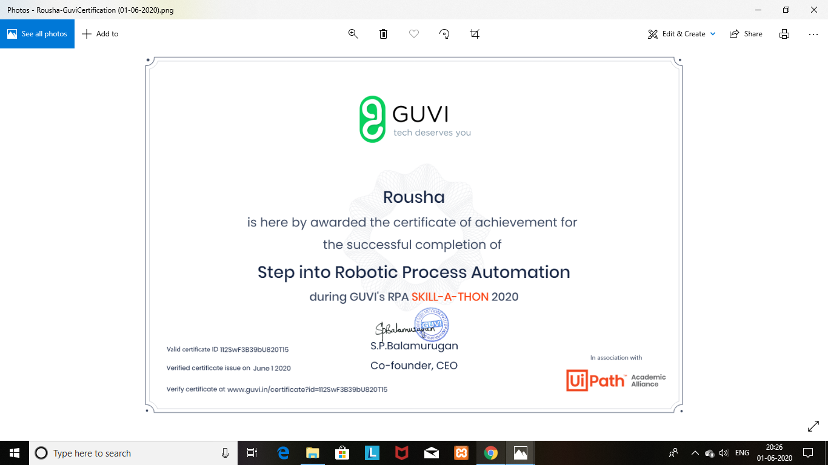

Coding Challenges Details: (Attach the snapshot and briefly write the report for the same)

Program1:

